For FD001:

Comparison between RUL_real and RUL_Predict, Residual Plot

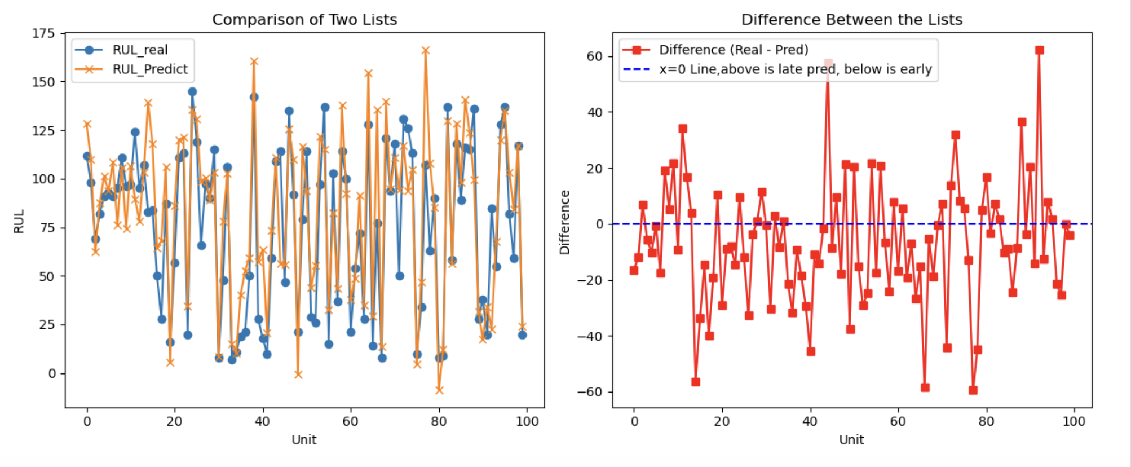

Residual and sMAPE distribution: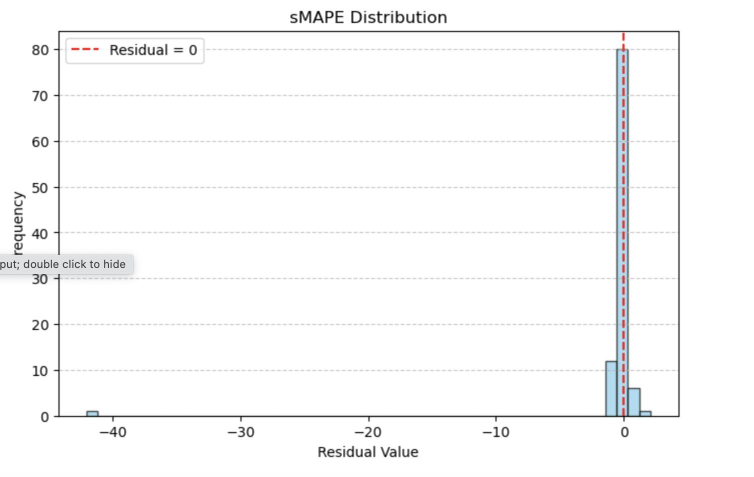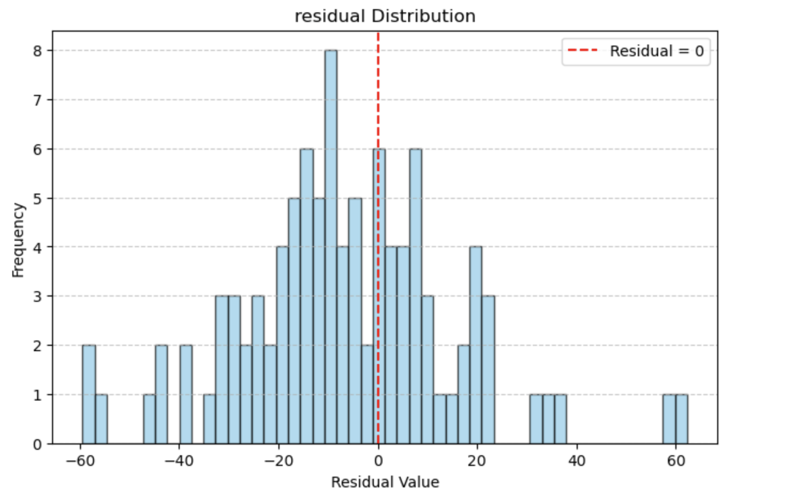

Example Unit Prediction (step size 10):

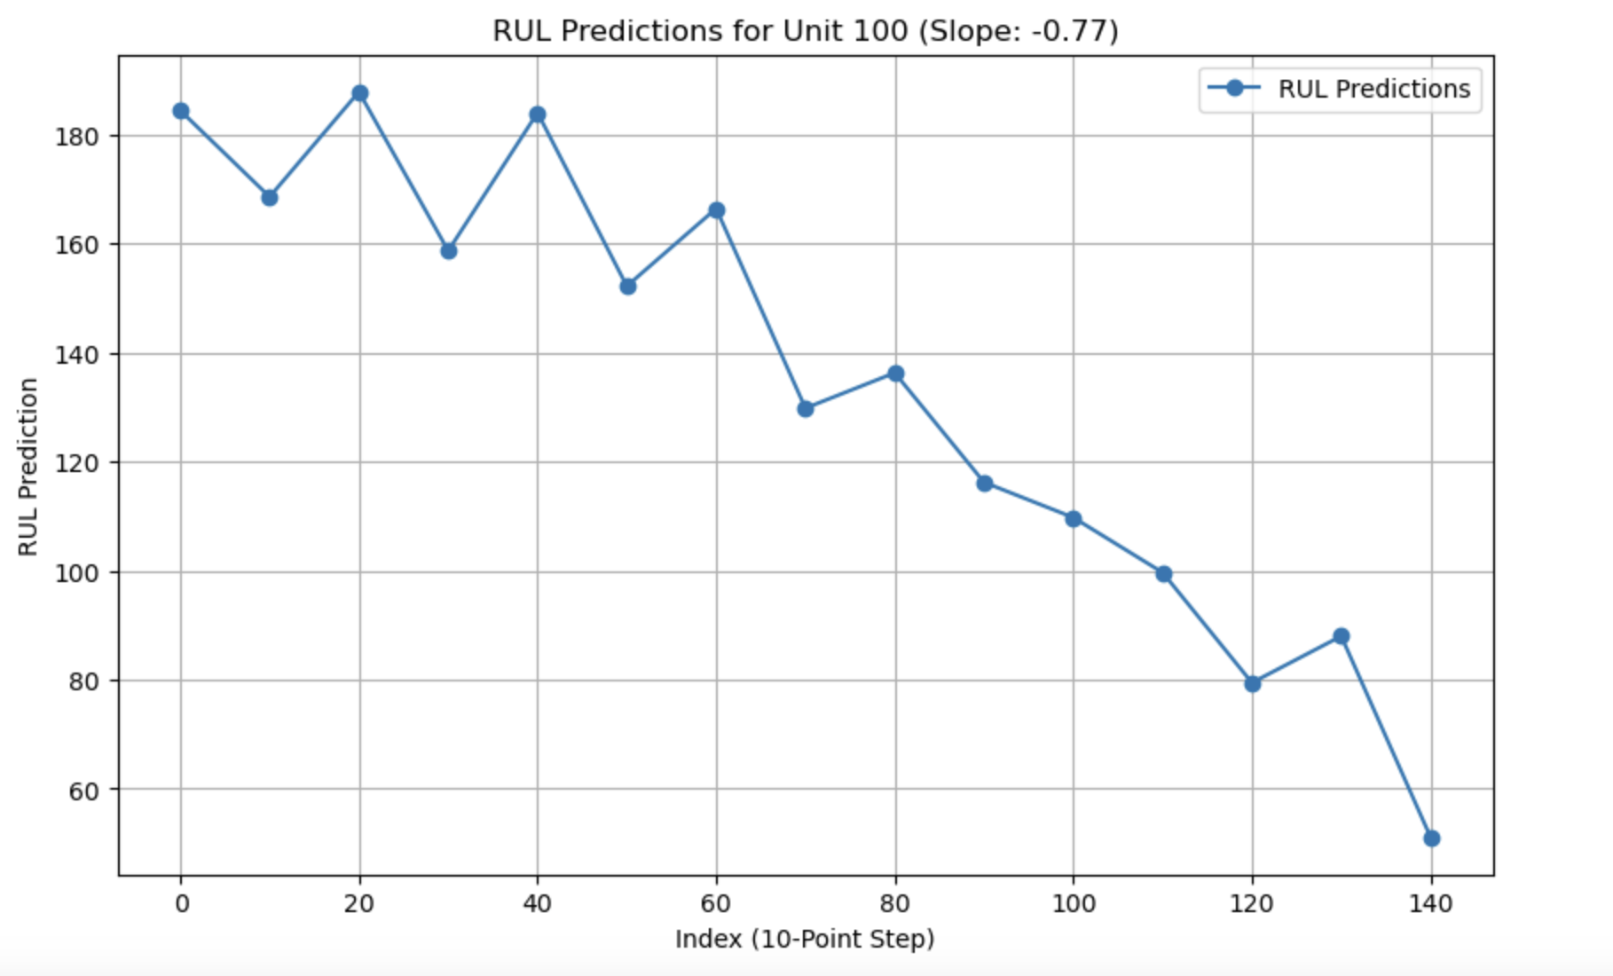

For FD002:

Comparison between RUL_real and RUL_Predict, Residual Plot

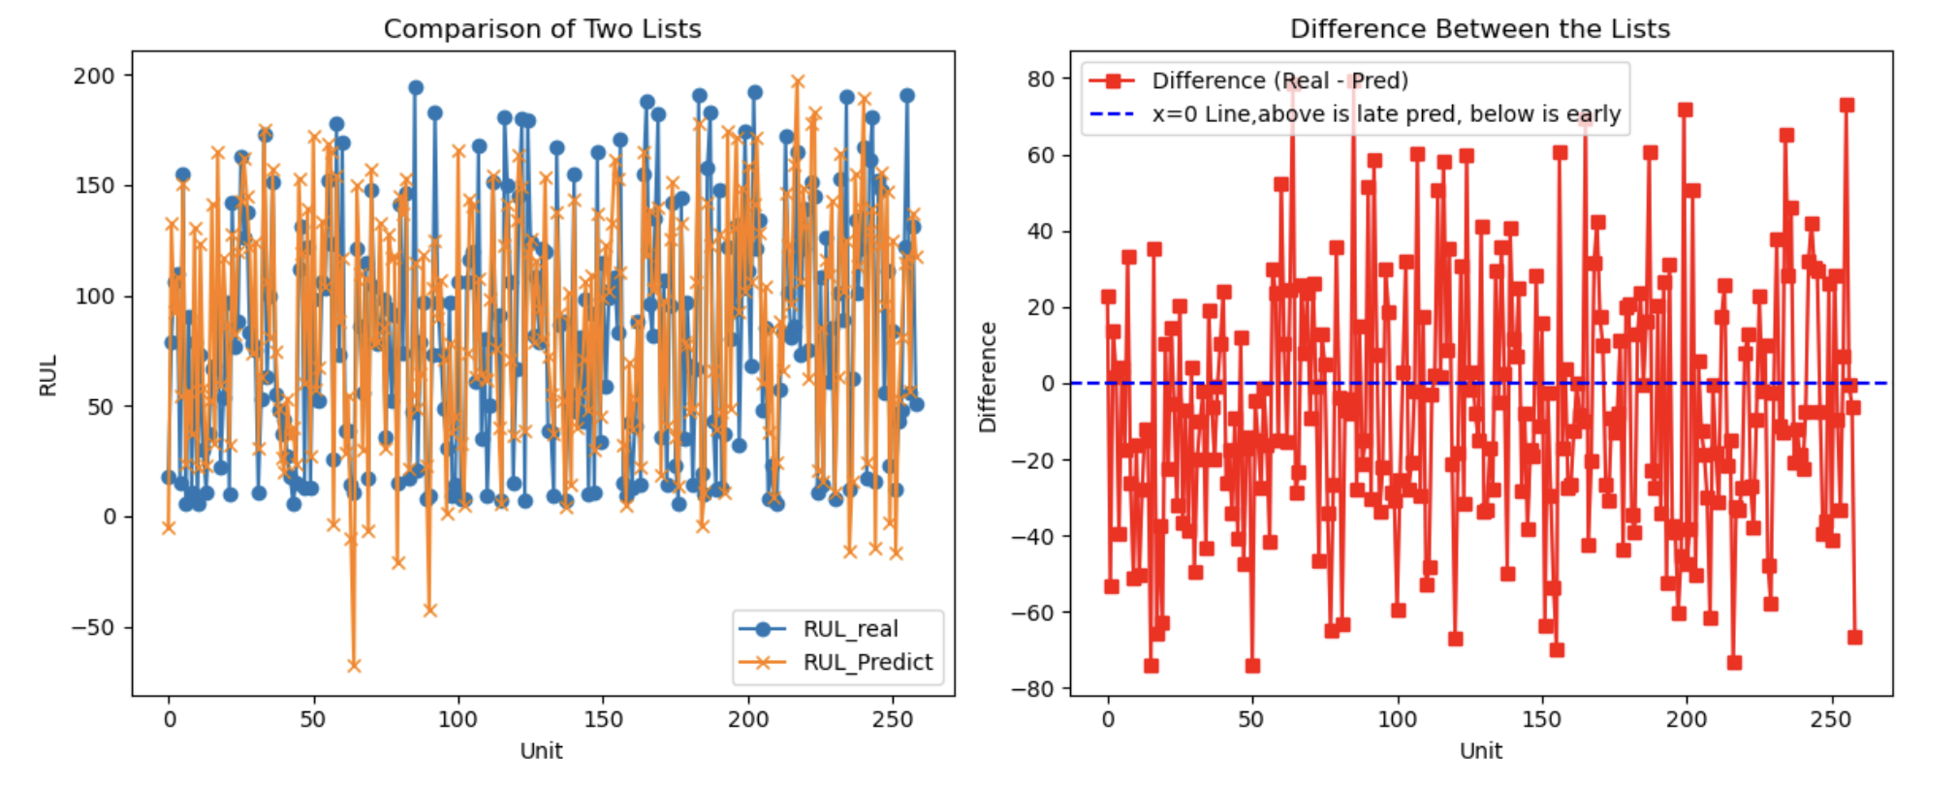

Residual and sMAPE distribution:

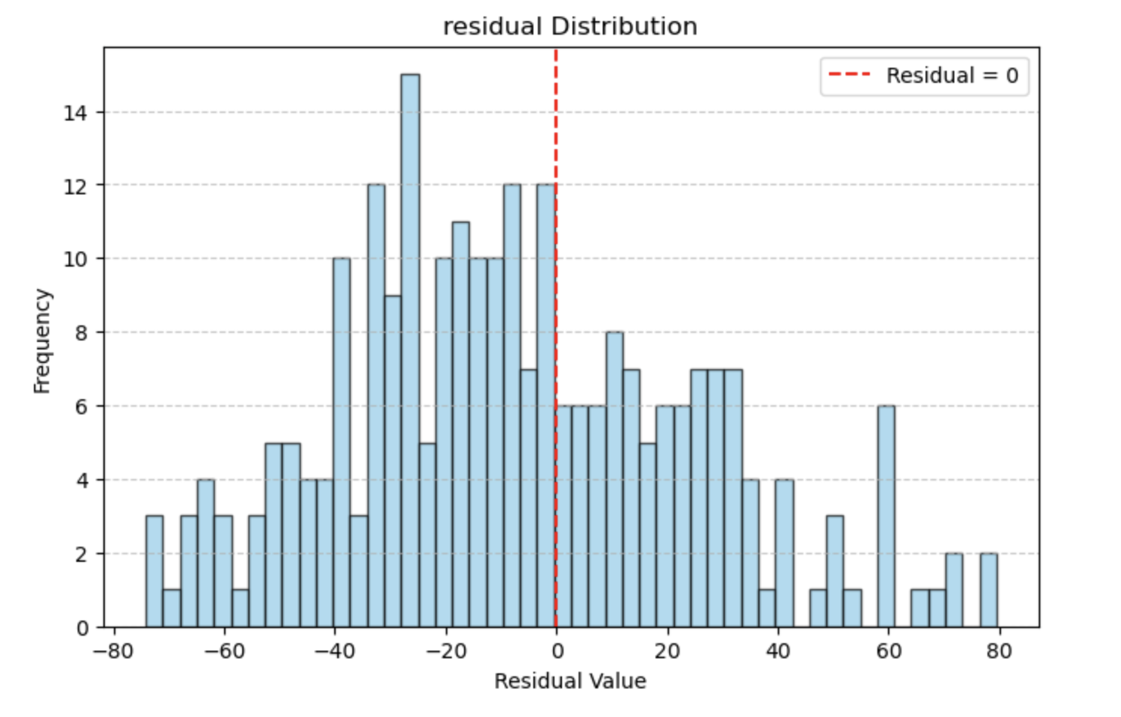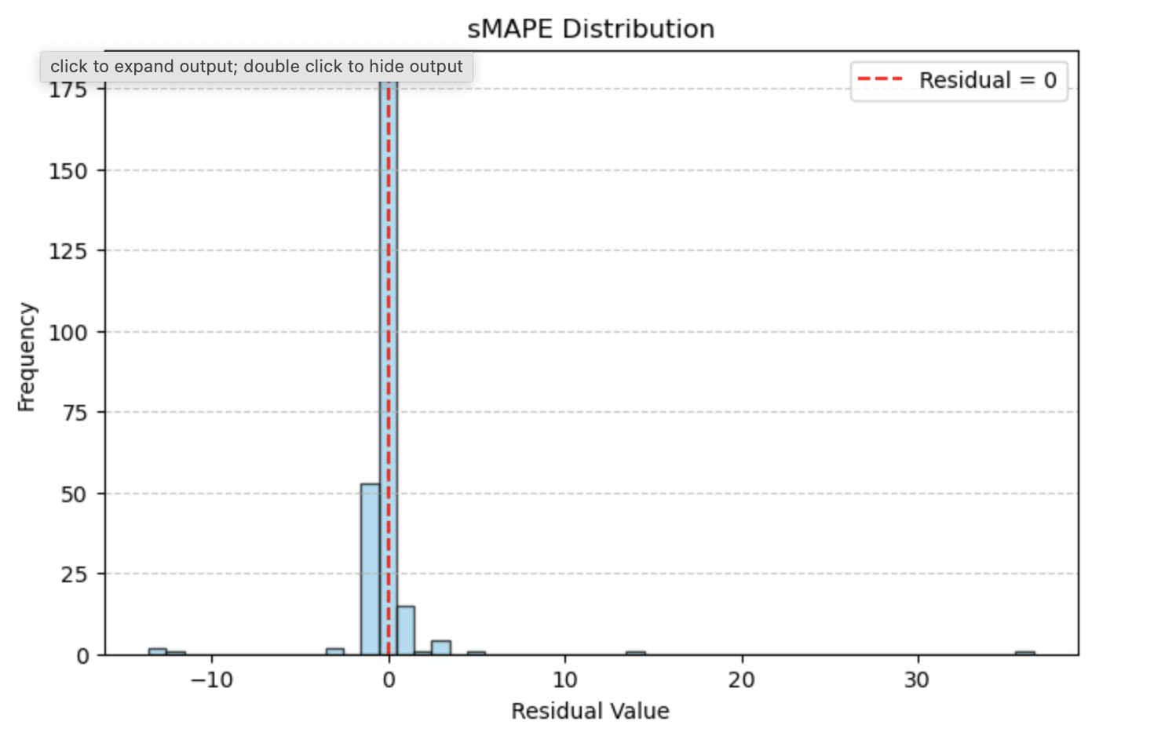

Example Unit Prediction (step size 10):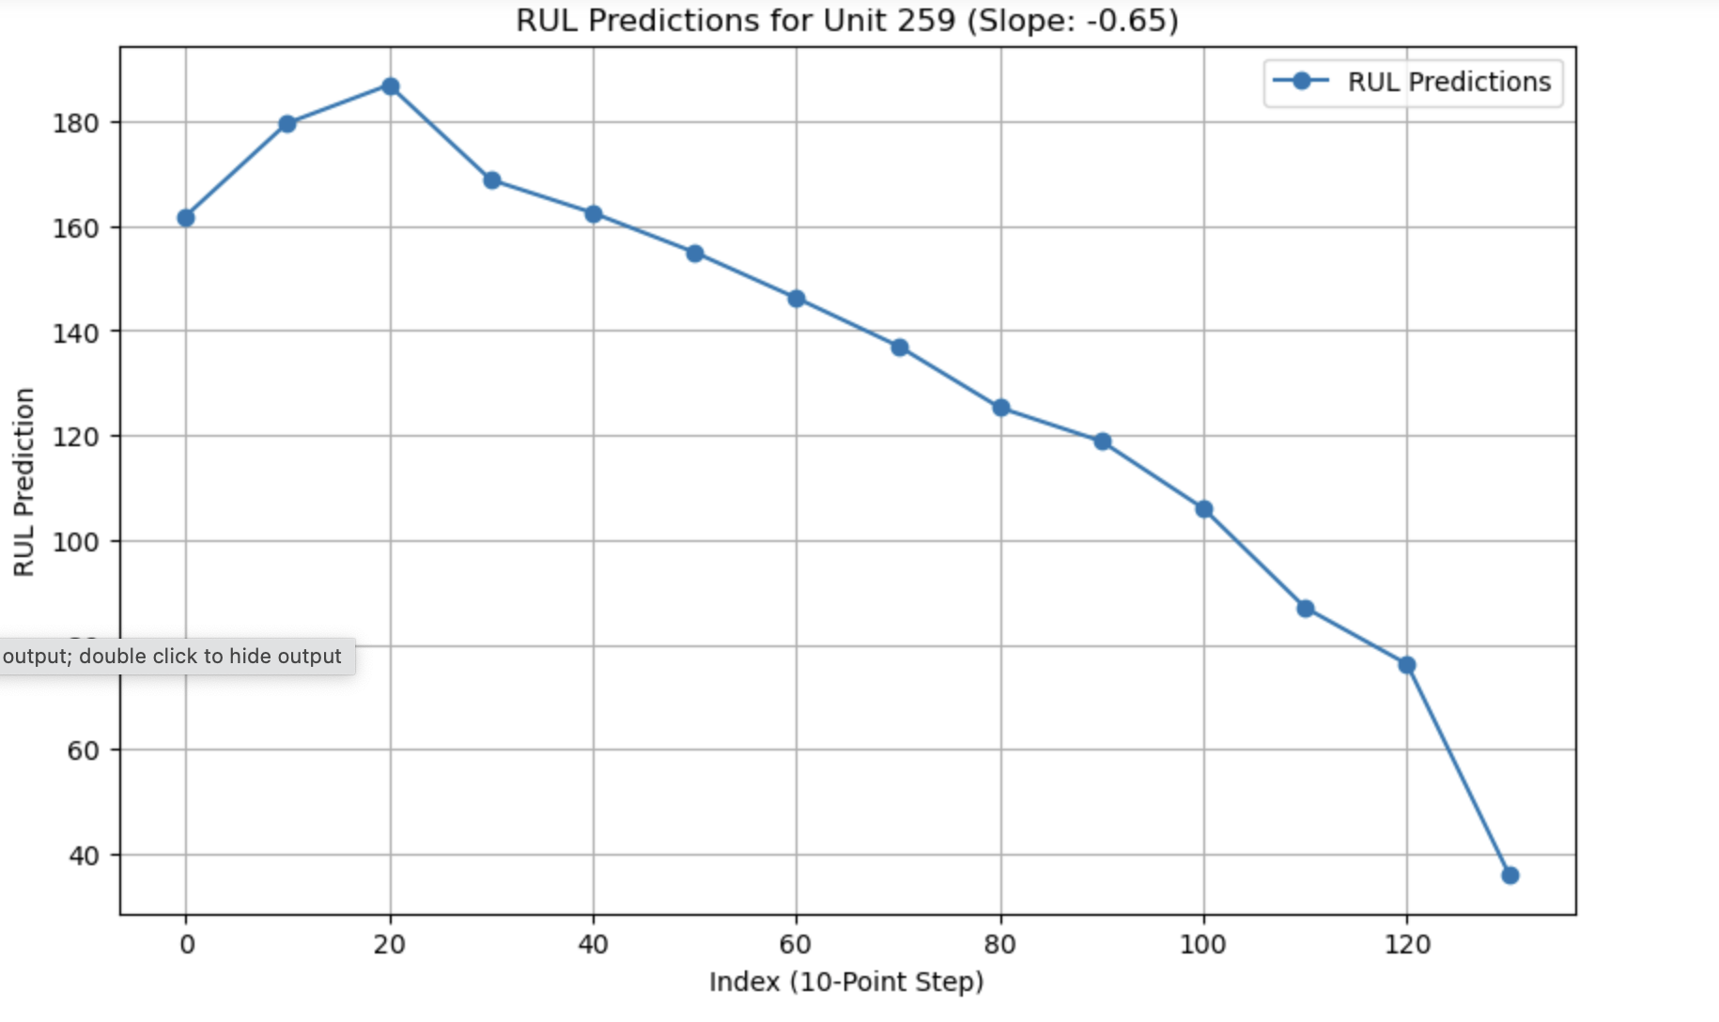

For FD003:

Comparison between RUL_real and RUL_Predict, Residual Plot

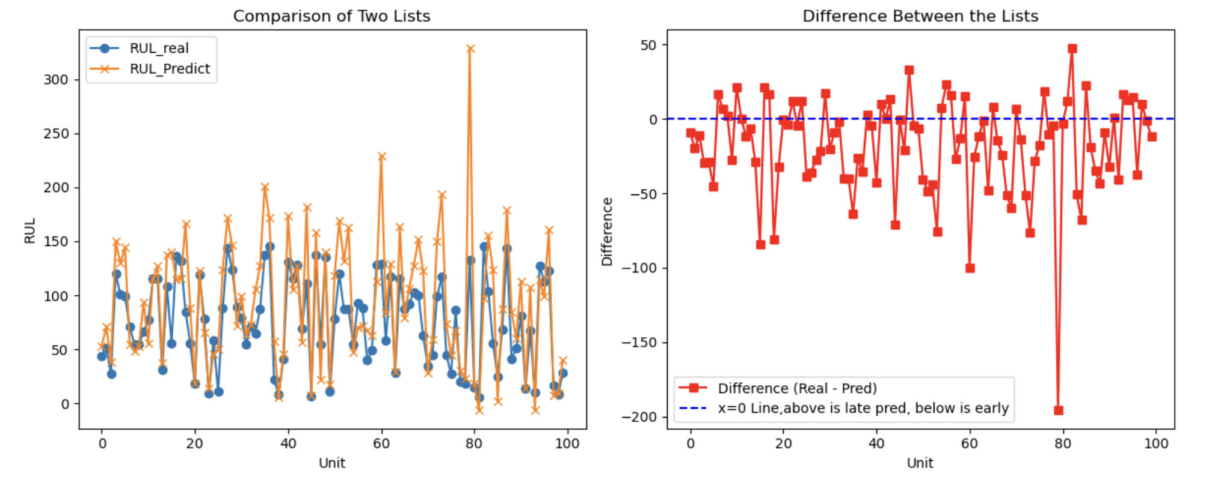

Residual and sMAPE distribution:

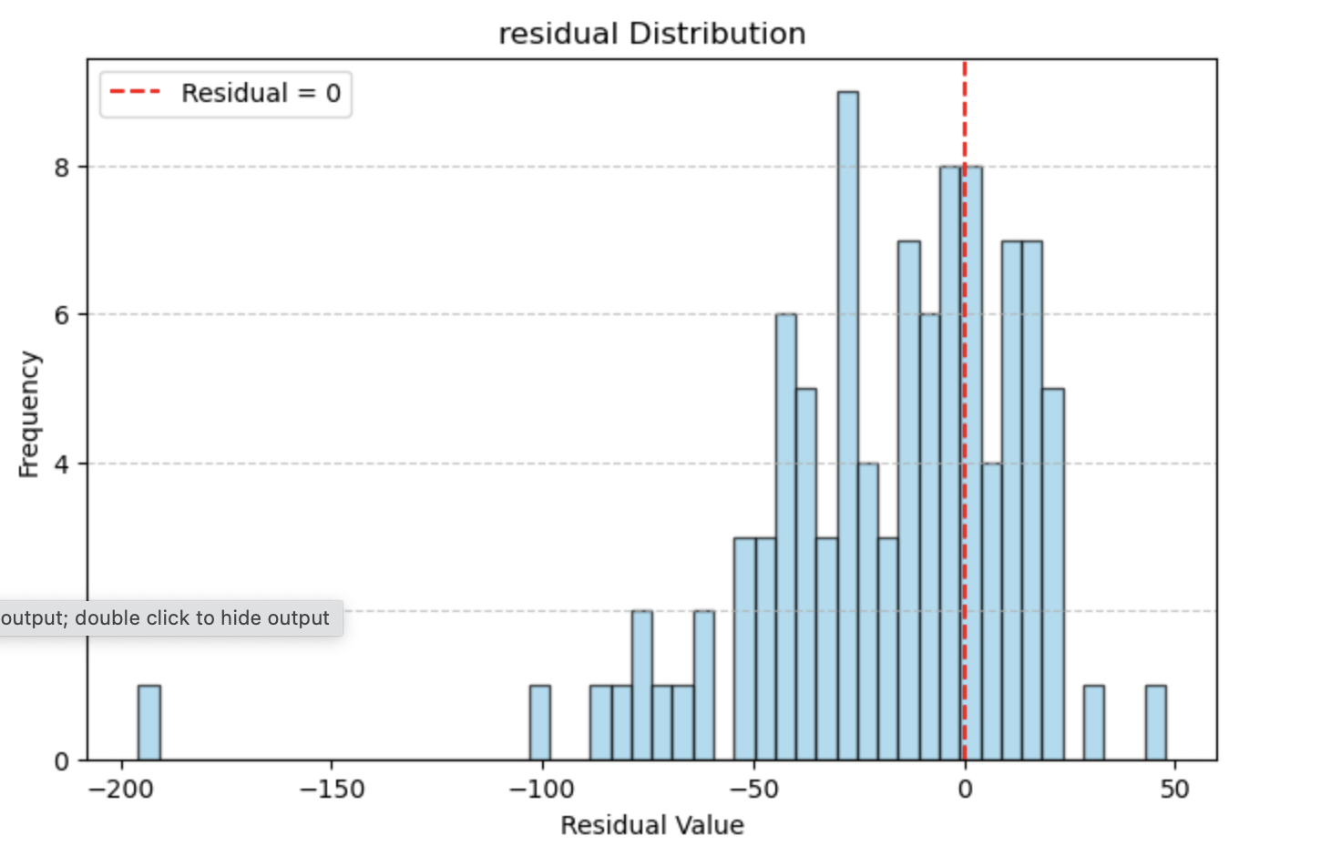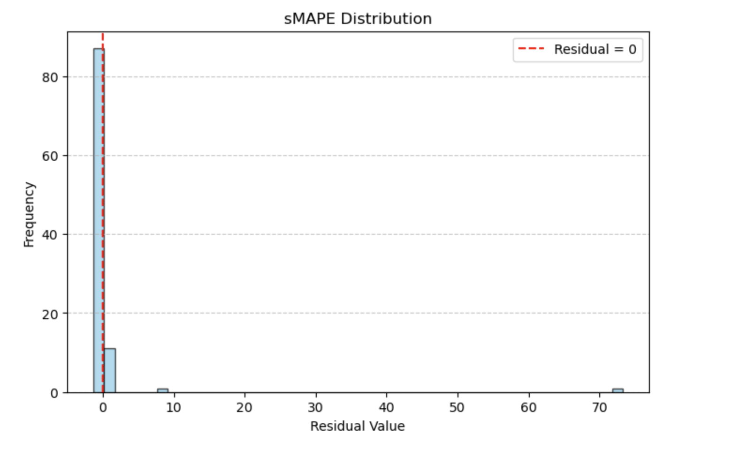

Example Unit Prediction (step size 10):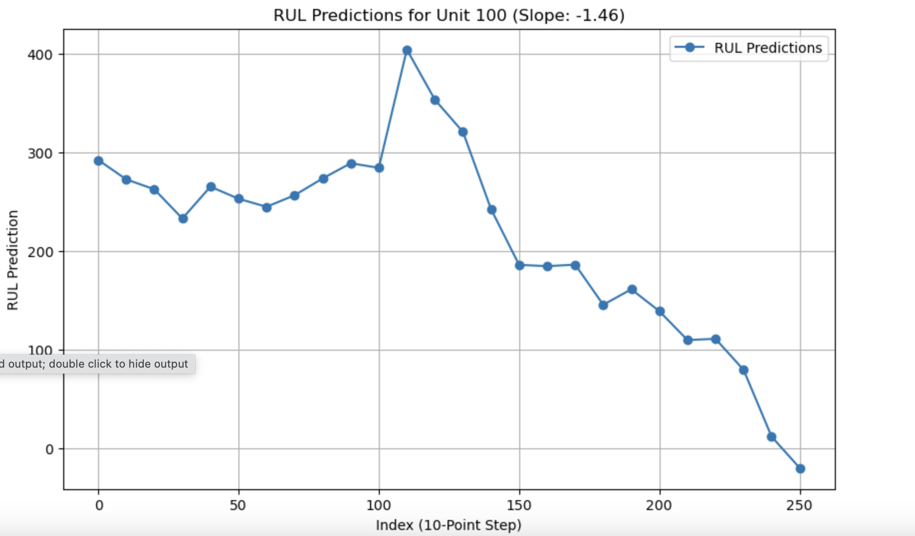

For FD004: